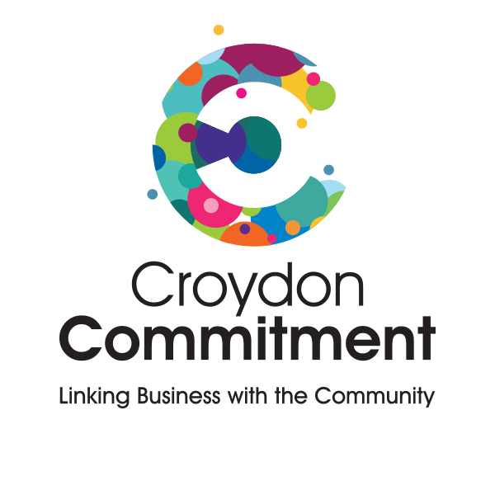Sponsorship and Events Policy

Charity Name: Croydon Commitment
Approved by Trustees on:
Review date:
Applies to: Trustees, staff, volunteers, and anyone involved in organising events or securing sponsorship on behalf of Croydon Commitment

1. Purpose of this Policy
Croydon Commitment organises events and accepts sponsorship to support its charitable purposes, raise funds, increase awareness, and engage with the community. This policy sets out how events and sponsorship will be managed responsibly and in line with governance requirements.

2. Scope
This policy applies to all events organised, delivered, or supported by Croydon Commitment and all event-related sponsorship, including financial and in-kind support. Events may include community events, fundraising activities, awareness-raising events, and online or hybrid events.

3. Principles
All events and sponsorship arrangements must further Croydon Commitment’s charitable purposes, be lawful and ethical, protect the charity’s independence and reputation, and be proportionate to the charity’s size and resources.

4. Events Organised by Croydon Commitment
Events must be planned in advance with clear objectives, roles, and responsibilities. Higher-risk or large-scale events must be approved by the trustee board. Events must be delivered in line with safeguarding requirements and the Events and Projects Risk Policy.

5. Risk Management and Safety
A proportionate event risk assessment must be completed. Safeguarding, health, and safety risks must be identified and managed. Any incidents or near misses must be reported and reviewed.

6. Sponsorship
Sponsorship may include financial contributions, goods, services, facilities, or promotional support connected to events or activities.

7. Acceptable and Unacceptable Sponsorship
Sponsorship will only be accepted where it aligns with the charity’s values, supports its aims, and does not compromise independence or involve party-political activity. Sponsorship that creates unacceptable risk or undue influence will not be accepted.

8. Due Diligence and Approval
Proportionate due diligence must be carried out on sponsors in line with the Corporate Due Diligence Policy. Significant or higher-risk sponsorship must be approved by the trustee board. All sponsorship income must comply with the Financial Controls Policy.

9. Financial Management
All event income and expenditure must be authorised, recorded, and monitored appropriately. Sponsorship income must be clearly recorded and distinguishable from donations.

10. Branding and Publicity
Use of Croydon Commitment’s name or logo by sponsors must be agreed in advance. The charity retains final approval over publicity and representation.

11. Political Neutrality
Events and sponsorship must not support or oppose political parties or candidates and must comply with the Campaigns and Political Activities Policy.

12. Conflicts of Interest
Any conflicts of interest relating to events or sponsorship must be declared and managed in line with the Conflict of Interest Policy.

13. Incidents, Complaints, and Escalation
Serious concerns arising from events or sponsorship arrangements must be escalated to the trustee board and managed in line with the Internal Risk Management Policy and Serious Incident Policy.

14. Linked Policies
This policy should be read alongside the Financial Controls Policy, Donations Policy, Corporate Partnerships Policy, Corporate Due Diligence Policy, Events and Projects Risk Policy, Conflict of Interest Policy, safeguarding policies, and the Serious Incident Policy.

15. Review of Policy
This policy will be reviewed at least every three years or sooner if circumstances change.

Signed (Chair of Trustees):
Date:

